Bahria University,

Karachi Campus



LAB EXPERIMENT NO. _01_

LIST OF TASKS

|  |  |
| --- | --- |
| TASK NO | OBJECTIVE |
| Task 1 | Write a C++ Program that read a float input from user and store it in variable *amount*. add 16 to an integer *num* if the value of amount in greater than 5.4. Print out the results of both variables on screen |
| Task 2 | Write a C++ Menu driven program that allows a user to enter five numbers and then choose between findings the smallest, largest, sum or average. Use else if statement to determine what action to take. |
| Task 3 | Write a C++ program that takes a positive integer from user and store it in variable *posNumber*. Follow these conditions;   * If the number is less than 1, print wrong input. * If it is 1, Print its value. * If value is greate than 1, check the value is it Even or Odd. * If it is Even, half it and print. * If it is Odd, multiply it by 3 and print result. * Repeat the whole process until user enter 1. |
| Task 4 | Create a program which implement an interface for simple calculator & use multiple data types to store answers and result and memory log.   * + - Develop an Algorithm for it.     - Create an interface for simple calculator.     - Implement interface in SimpleCalculator class. |
| Task 5 |  |
| Task 6 |  |
| Task 7 |  |
| Task 8 |  |

Submitted On:

__29/03/19__

(Date: DD/MM

**Task No. 1:** Write a C++ Program that read a float input from user and store it in variable *amount*. add 16 to an integer *num* if the value of amount in greater than 5.4. Print out the results of both variables on screen.

**Coding:**

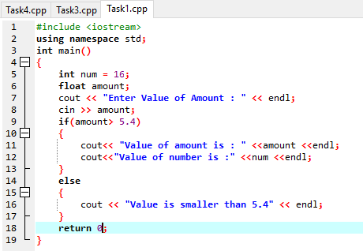

**Output:**

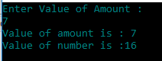

**Task No. 2:** Write a C++ Menu driven program that allows a user to enter five numbers and then choose between findings the smallest, largest, sum or average. Use else if statement to determine what action to take.

**Coding:**

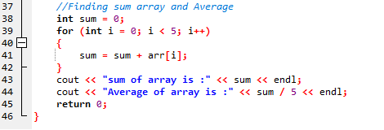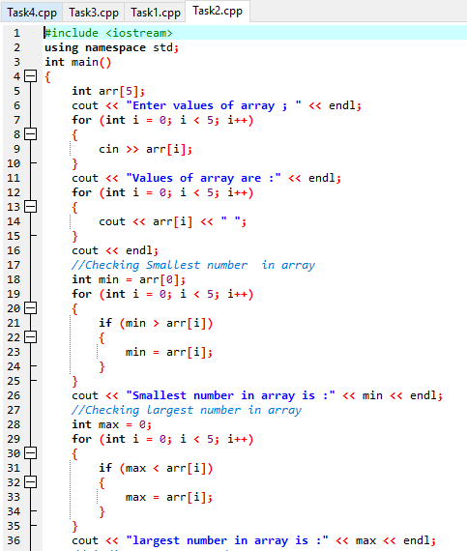

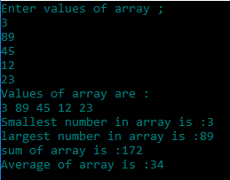**Output:**

**Task No. 3:**Write a C++ program that takes a positive integer from user and store it in variable *posNumber*. Follow these conditions;

* If the number is less than 1, print wrong input.
* If it is 1, Print its value.
* If value is greate than 1, check the value is it Even or Odd.
* If it is Even, half it and print.
* If it is Odd, multiply it by 3 and print result.
* Repeat the whole process until user enter 1.

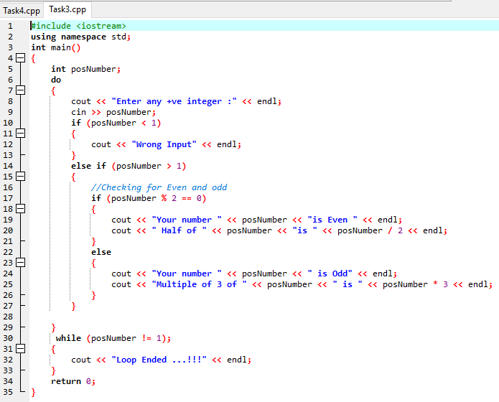**Coding:**

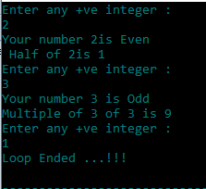

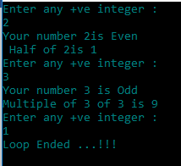**Output:**

**Task No. 4:** Create a program which implement an interface for simple calculator & use multiple data types to store answers and result and memory log.

* + - Develop an Algorithm for it.
    - Create an interface for simple calculator.
    - Implement interface in SimpleCalculator class.

**Coding:**

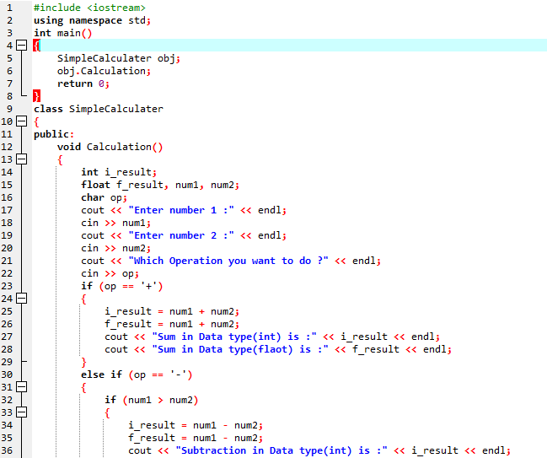

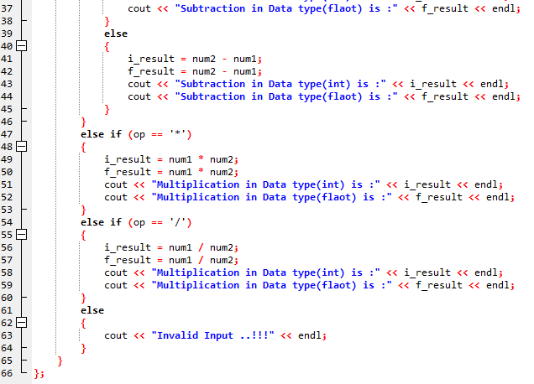

**Output:**

